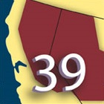
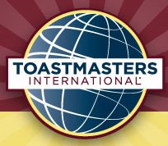
Toastmasters
Area 54
Table Topics and International
Speech Contests
Saturday, March 18, 2017
Sacramento County Administration Building
700 H Street, Sacramento, CA

Area 54
Capital Communicators Club
Golden State Capitol Toastmasters
Aesop’s Fablers
East End Orators
River City Toastmasters

8:30 a.m. Doors Open, Refreshments, 8:45 a.m. Contestant Briefings
9:00 a.m. Table Topics Contest followed by the International Speech Contest

Division E Contests:
Friday, April 7th, 700 H Street,
Sacramento, California

District 39 Contests:
Saturday, May 20th, Gaia Hotel and Spa,
Andersen, California

District 39: www.district 39.org

John Heredia - Area 54 Director john.heredia@district39.org

