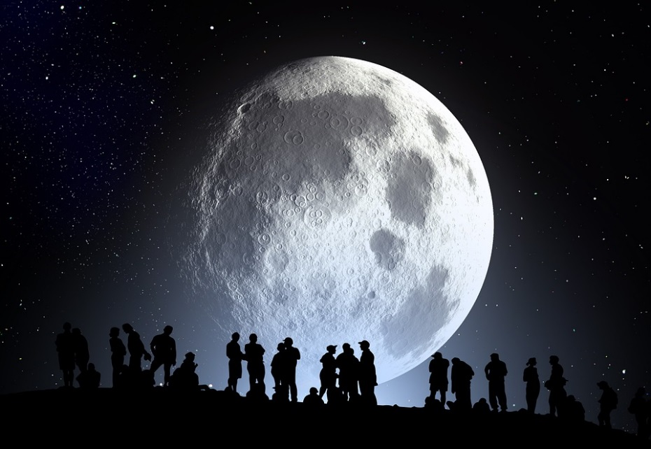

Full Moon August Barbeque

The Original Articulators invite you to share this Spectacular Mid-summer event with them.
Friendship
Food
Fun

Meat, plates, and utensils will be provided.
Please share a salad, appetizer, side dish, or dessert.
 | Saturday, August 25, 2018  6 pm to 10 pm  Add location  Games | RSVP:  Add names and phone numbers

