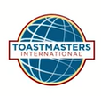
Area 53 Toastmasters Clubs are hosting an OPEN MIC TABLE TOPICS LUNCH EVENT
Thursday, February 15, 12:00-1:00 PM
Blue Prynt Restaurant and Bar
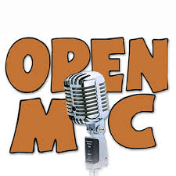
This event is open to:
- ALL TOASTMASTERS CLUBS!
- ALL PROSPECTIVE MEMBERS!
- ALL NON TOASTMASTERS!
Come to try your skills at impromptu speaking while enjoying lunch (you buy your own off their menu).
Join us at Blue Prynt, 815 11th Street, corner of 11th & H Streets. Please arrive at 11:45 AM to register your attendance and sign up if you want to compete. Then you will order your lunch off the menu.
For more information, contact Bill Dean bill.dean@district39.org
Other Open Mic Opportunities coming up soon:
- February 16, 5:30 – 7:30, Hosted by River City Speakers, Blue Prynt Restaurant and Bar, 815 11th Street
- March 9, 2018, 5:30 – 7:30, Hosted by River City Toastmasters, Kupros Craft House, 1217 21st Street

